**Real-Time, Non-Contacting Position Tracking of Medical Devices and Surgical Tools through the Analysis of Magnetic Field Vectors**

Mohammad Odeh1

Edward Daniel Nichols1

Fluvio Lobo1

Jack Stubbs1

Institute for Simulation and Training, Center for Applied Research, University of Central Florida1

***RED, BOLD, ITALICS* Need to be reviewed for editing, double-checked for accuracy, or updated as the system progresses.***

# 1 Background

As the demand for increasingly advanced invasive medical procedures rises with the average age of the population, it also becomes increasingly compelling to facilitate and extend the spatial awareness and dexterity of surgeons, both human and robotic. One may accomplish this by tracking an object digitally and representing its form and motion in a close virtual model of the area around an incision, such as through an augmented reality platform. Several groups across a diverse range of academia and industry have competed to develop marginal improvements to methods of digitally tracking objects [1, 3, 5, and 6]. In the entertainment industry in particular, object tracking is a fundamental way of bringing life-like motion to an object represented in virtual space. The generally accepted approach is to use expansive, multi-camera computer vision (CV) systems to yield real-time tracking [4]. However, this approach is not suited for medical applications; CV is limited by a strict field of view. Accurately tracking surgical instruments inside of organic tissues must then be done another way.

Of the methods presently being investigated, none are as applicable in a medical context as magnetic field sensing. Human tissues are permeable to magnetic flux, and magnetic fields are well characterized. Upon this motivation, we have constructed an inexpensive device from off-the-shelf parts that enables the tracking of a permanent magnet on surfaceto serve as a foundation for future work in this field.

# 2 Methods

## 2.1 Analytical Foundation

Electromagnetic fields are characterized by fundamental principles. Given a classic magnetic dipole centered at the origin, its magnetic induction can be expressed as:

|  |  |
| --- | --- |
|  | (1) |

Whereby the relationship is dependent on the orientation and strength of its magnetic moment vector, given by , as well as the location of the arbitrary point of interest with respect to the center of the magnet, represented by vector . Equation (1) can be modified to express the strength of the magnetic field **,** which is what an observing magnetometer normal to the level surface of the magnetic field would perceive; which may further be broken into a more convenient polar component form, given the intrinsic rotational symmetry of isofield lines about .

Based on the work of Chen *et al* [5], expressing the location of the center of a magnet with respect to the magnetic field vectors observed by three sensors in predefined relative positions fully satisfies a system of equations when the magnet is in a fixed North pole orientation along the system’s internally defined z-axis:

|  |  |
| --- | --- |
|  | (2) |
|  | (3) |
|  | (4) |

Whereby, represents a sensor in the array, is the distance to the center of the magnet for the sensor, is the relative offset from a designated origin with respect to the sensor, represents the angle made by the north pole of the magnet and the radial component of, and K represents a constant that encompasses the magnitude of the dipole moment, magnetic permeability of free space, and the relative permeability of the magnet’s own material.

However, one must maintain certain minimum assumptions for a solution to converge numerically.

1. An origin must be defined with respect to the relative fixed positions and orientations of the sensors.
2. The constant value of the magnetic field strength coefficient K of an arbitrary magnet has been closely approximated, or is otherwise known.
3. A constant magnetic field source of perceivable threshold exists within range of at least three sensors in the sensor array.

In addition, to refine accuracy, certain physical restrictions facilitate these conditions.

1. Ambient magnetic fields must be mitigated; or the signal must be otherwise overcome.
2. The magnet’s form factor is minimized to yield closer adherence to presupposed principles.

To begin achieving these conditions, we designate the sensor in the bottom left corner of our array to be the origin. All sensors’ axis in the array are aligned with each other.

## 2.2 Empirical Approximation of K

|  |  |
| --- | --- |
|  | (5) |

Equation (5) is derived from Eqns. (2), (3) and (4) if motion occurs along a single axis, namely, *x***.**

Empirically approximating the value of K for an arbitrary dipole magnet can then be done procedurally. We have done this precisely using a custom CNC machine. As follows:

1. The magnet is placed at a distance of 75mm away from sensor *i* such that (, , ) and (, , ).
2. A sample of K is computed from for sensor *i*.
3. The magnet is moved =10mm to (, , ).
4. Another sample of K is computed from a new .
5. Steps 3 and 4 are repeated multiple times, recording the values of x, and K each time.
6. An approximated result of K yields from averaging the sampled points.

Readings of and should be minimized to ensure accuracy; and condition is satisfied when and. As long as both the approximated value of K yields physically reasonable position solutions. Nonetheless, the closer and are to zero the better the approximation. Crucially, an approximation derived this way is physically reliable within the signal detection range of the sensor array.

## 2.2 Sensor Array

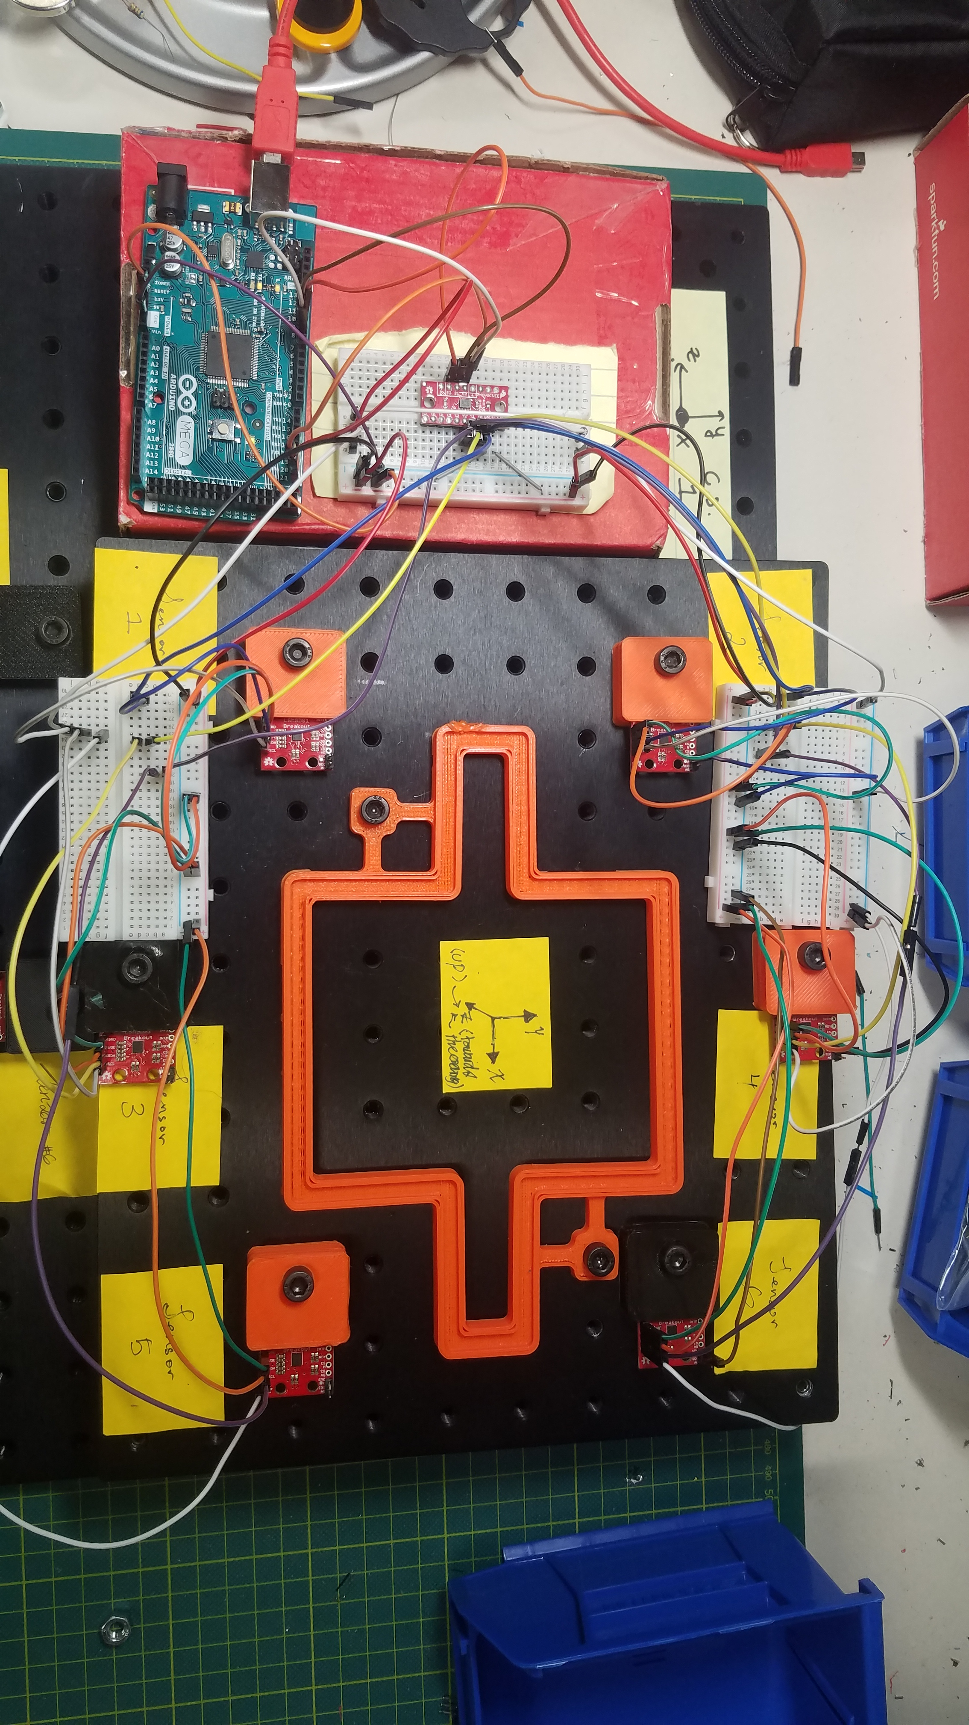

Figure 1: Sensor Array with a 3D printed magnet test track inside.

Only three sensors are required to derive a location, but more were added to extend the range. The array is comprised of six *Sparkfun LSM9DS1 IMU* *breakouts* arranged in a circular pattern around a central area. They are switched to by a *Sparkfun 74HC4051 8-channel* *multiplexer* *breakout*, and data is driven through an Arduino compatible microcontroller, such as a *PJRC Teensy v3.2* via I2C on both available *IMU* addresses. This information is then lightly formatted and output, line by line, through Serial Bus to a capable Python script on a PC.

Sensor readings are taken by the IMUs at 80Hz, yielding the XYZ components of with respect to the sensor orientation. Geomagnetism is partially accounted for with the IMUs’ built-in function given a local declination. To mitigate the effect of remaining ambient magnetic fields, sensor readings are averaged over 50 readings, for each sensor, upon reset and the respective result is subtracted from later readings. Drifting is observed to be minimal, yet further mitigation is left as future work. Readings henceforth start at ±20 milliGauss and range to ±16 Gauss, according to the built-in 16-bit analog to digital converter in the IMU chip. This information for each sensor is output by themicrocontrollerto the PC, where it is split and sorted by the Python script.

## 2.3 Position Tracking Algorithm

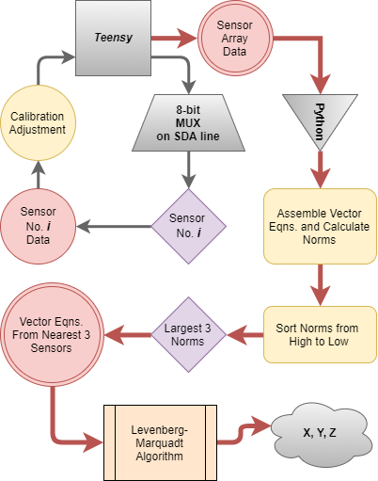

Figure 2: System Flowchart

Each sensor allows the script to assemble one possible input equation according to Eqns. (2), (3) and (4) for six coupled equations. As can be observed, the constructed system of equations is non-linear and has no analytical solution, thus the need for a numerical technique to aid in the computation of the magnet’s position arises. Computation begins after the script has assembled the nonlinear system of equations and chosen the three rendered from the sensors calculated to have the largest respective to pass to a Levenberg-Marquardt algorithm (LMA) powered by the versatile *SciPy* module. The reason that only three equations are being considered during the computation process stems from the fact that *SciPy*’s implementation of the LMA lacks support for overdetermined systems of equations.

LMA was chosen for its robustness and speed of convergence. Its accessibility within *SciPy*, notwithstanding. Furthermore, since LMA combines Newton-Raphson’s algorithm and the Steepest Descent method, it converges to a solution even if the initial guess is far off the mark. Yet, to reduce computation time, the script performs a dynamic search of the possible initial guesses by determining the possible location of the magnet in accordance to which three sensors are reading the highest magnetic field. The initial guess is then determined as the centroid of the triangle formed by the three sensors and is fed into the LMA.

A permanent magnet is chosen as the source and it is assumed to have an ideal magnetic dipole field at long-distance. It does not have to be powered, so it simplifies our design and aligns well with the medical applications in mind.

# 3 Results

Given the demonstrated success of others operating under a similar approach [2, 6 and 7], our focus becomes refining the system for operational efficiency. ***However, we conducted a series of trials to verify and characterize the system’s accuracy and precision, especially in pursuit of our lab’s application, in 2D space.***

## 3.1 Point Accuracy

Using a metric optics breadboard with 25mm separation between through-hole taps, a 30mm diameter permanent magnet, and 3D printed magnet jigs, output was sampled at convenient, known points on a plane level with the sensors. Several hundred output samples were taken for each point.

|  |  |
| --- | --- |
| *Distance Error from (100mm, 100mm, 0mm)* | |
| **Mean** | **3.774** |
| Standard Deviation | 0.510 |
| Sample Variance | 0.260 |
| Kurtosis | 0.749 |
| Skewness | -0.140 |
| Range | 4.064 |
| Minimum | 1.614 |
| Maximum | 5.678 |
| Count | 576 |

Figure 3: Example of descriptive statistics for the data sampled from the system with the center of the 30mm diameter magnet mounted on a jig at the point  
 (100mm, 100mm, 0mm).

After 20 points were sampled, a mean “distance error” was calculated for each point. We take then a mean of means to return a more complete reported precision of within 1.5mm for a 30mm magnet with an approximated value of K.

|  |  |
| --- | --- |
| *System Distance Error (mm)* | |
|  |  |
| **Mean of Means** | **1.402** |
| Standard Deviation | 0.774 |
| Sample Variance | 0.599 |
| Kurtosis | 3.802 |
| Skewness | 1.642 |
| Range | 3.325 |
| Minimum | 0.449 |
| Maximum | 3.774 |
| Count | 20 |

Figure 4: Reported System Error from 20 samples.

## 3.1 Motion Tracking

Furthermore, we designed and 3D printed a few arbitrary tracks to place on our breadboard…

**[FLUVIO CONTINUES HERE]**

**[MENTION TRIAL TIMES AS COROLLARY TO THROUGHPUT RATE]**

**[ALSO, IT MAY ALREADY BE TOO LONG; WE’LL HAVE TO TALK ABOUT CONDENSING THE PAPER]**

The results are;

1. ~~Sensor array for real-time, non-contacting tracking of an object along a plane~~
2. An robust algorithm for the real-time, no-contacting tracking of an object in space (3)

The robustness of our sensor arrays (devices) and analysis software was evaluated in terms of;

* Examples of data plot
* Speed of the data
* ~~Accuracy and precision~~

# 4 Interpretation and Future Work

***We encounter many limitations in the present form of the system, indirectly related to the demonstrated principle, such as sensor readings’ drift affecting the distance error, limited software stability driving throughput inefficiency, a lack of a virtual 3D visualization of the output for ease of use, etc.*** Hence, further optimization is required, especially and including, a more robust mitigation of ambient fields and the throughput rate (which is heavily dependent on computation time). Finally, a thorough characterization of the system’s performance in 3D space, especially at random orientations of the magnet, must still be done.

Moving forward beyond these present preoccupations, with our medical applications in mind, we intend to improve upon the system, by optimizing the execution of LMA with better initial guesses and smoother data inputs; enable the approximation of a magnet’s orientation, by tracking the path of the magnet and the sensor array’s magnetic field vector components across time; increase the measurement accuracy, by refining approximations of K; miniaturizing the device to a more convenient form; and moving to more complex multi-pole objects, such as combinations of magnets; and building a 3D visualization of system output in real-time.

# References

[1] Han, X., Seki, H., Kamiya, Y., and Hikizu, M. “Wearable handwriting input device using magnetic field Geomagnetism cancellation in position calculation.” *Precision Engineering* Vol. 33 Issue 1 (2009), pp: 37-43. DOI 10.1016/j.precisioneng.2008.03.008.

[2] Han, X., Seki, H., Kamiya, Y., and Hikizu, M. “Wearable handwriting input device using magnetic field 2nd report: Influence of misalignment of magnet and writing plane.” *Precision Engineering* Vol. 34 Issue 3 (2010), pp: 425-430. DOI 10.1016/j.precisioneng.2009.12.005

[3] Raab, F., Blood, E., Steiner, T., and Jones, H. “Magnetic Position and Orientation Tracking System” *IEEE Transactions on Aerospace and Electronic Systems* Vol. AES-15 No. 5 (1979), pp: 709-718

[4] Moeslund, T., and Granum, E. “A Survey of Computer Vision-Based Human Motion Capture.” *Computer Vision and Image Understanding* Vol. 81, Issue 3 (2001), pp: 231-268. DOI 10.1006/cviu.2000.0897

[5] Chen, K., Lyons, K., White, S., and Patel, S. “uTrack: 3D Input Using Two Magnetic Sensors” In *Proceedings of the 26th Annual ACM Symposium on User Interface Software and Technology (UIST 2013).* pp: 237-244. St. Andrews, UK, October 8th-11th, 2013. DOI 10.1145/2501988.2502035

[6] Chen, K., Patel, S., and Keller, S. “Finexus: Tracking Precise Motions of Multiple Fingertips Using Magnetic Sensing” In *Proceedings of the 2016 CHI Conference on Human Factors in Computing Systems (CHI 2016), ACM.* pp: 1504-1514. San Jose, California, USA, May 7th-12th, 2016. DOI 10.1145/2858036.2858125

[7] Yoon, S., Huo, K., and Ramani, K. “TMotion: Embedded 3D Mobile Input using Magnetic Sensing Technique” In *Proceedings of the Tenth International Conference on Tangible, Embedded, and Embodied Interaction (TEI 2016), ACM.* pp: 21-29. Eindhoven, Netherlands, February 14th-17th, 2016. DOI 10.1145/2839462.2839463